**DATA SCIENCE (UCS548)**

**DASHBOARD**



**Property Value Analyzer**

**Submitted By:**

Darpan Kumar Mittal

102003710

**Submitted To:**

Mrs. Archana Singh

July 2022 – December 2022

**Main Dataset**

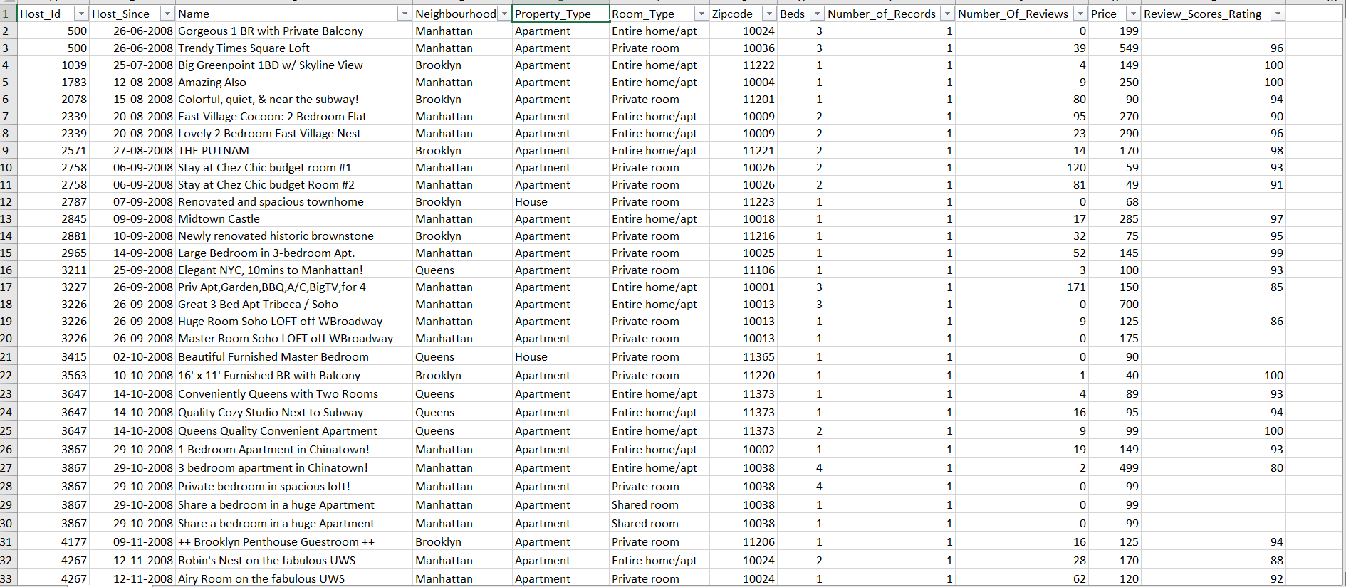

**Data Pre-processing**

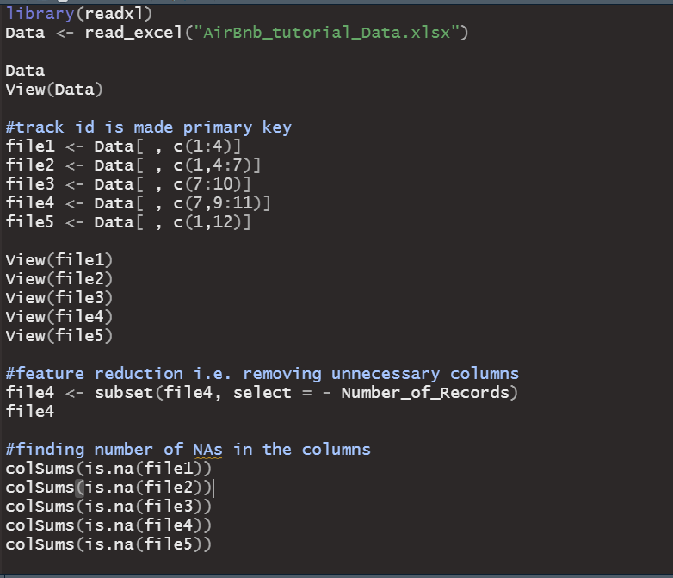

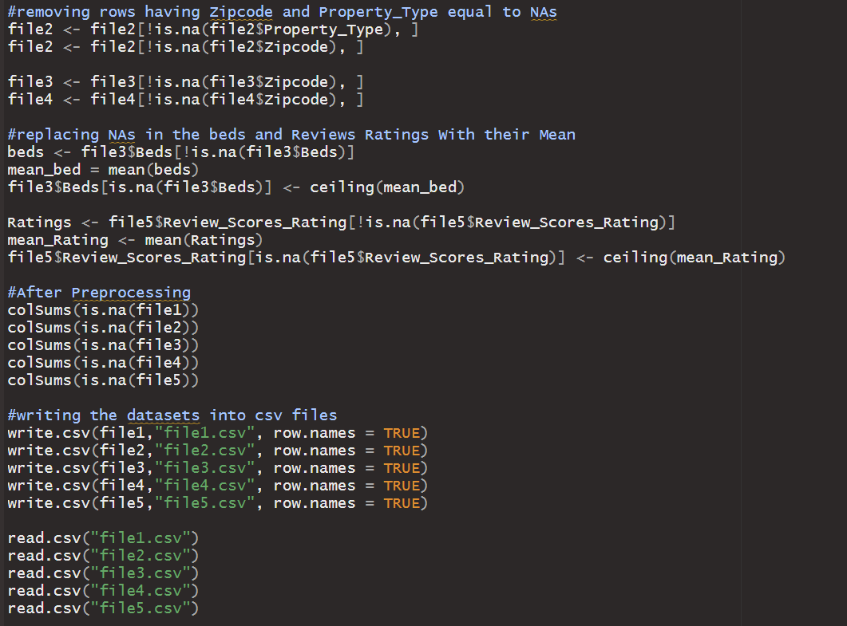

**Output :**

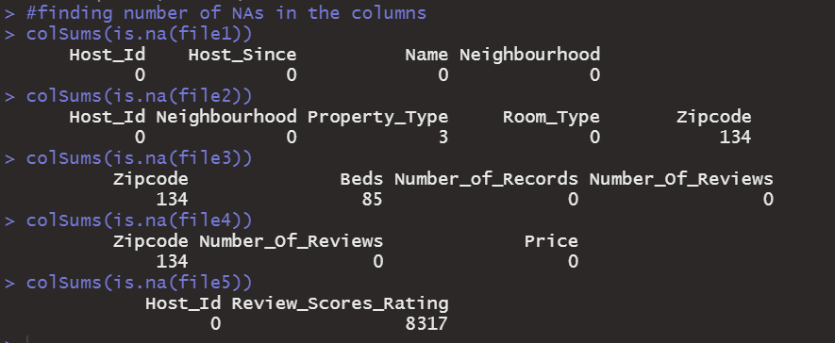

**After-Preprocessing :**

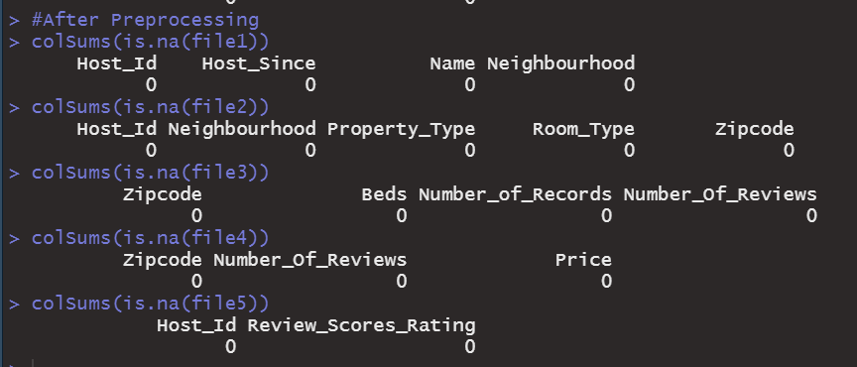

**After Splitting the Main Excel File, we have generated 5 csv files.**

1. **File.csv**

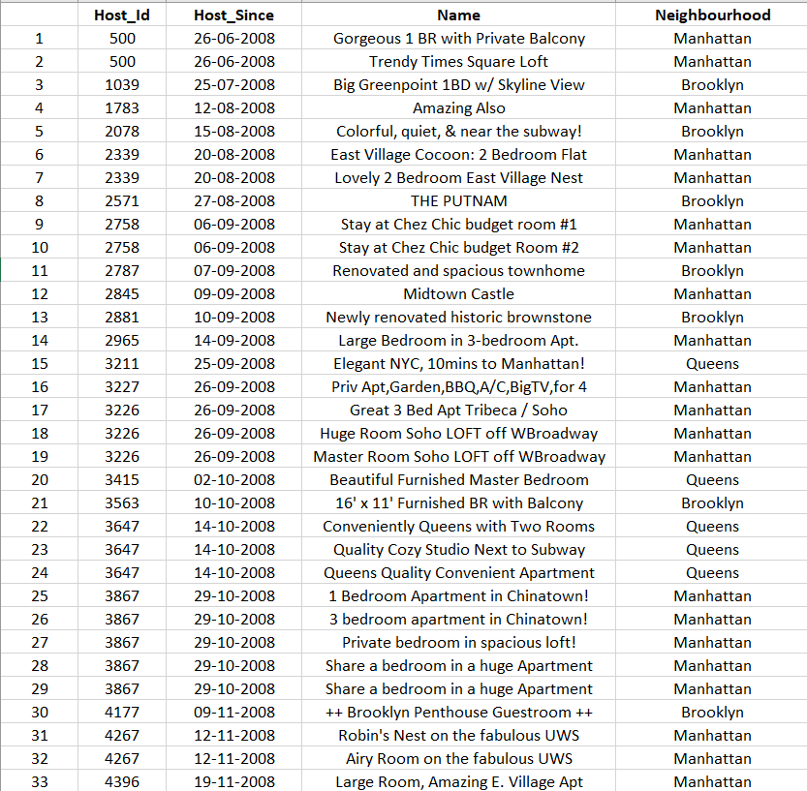

1. **File2.csv**

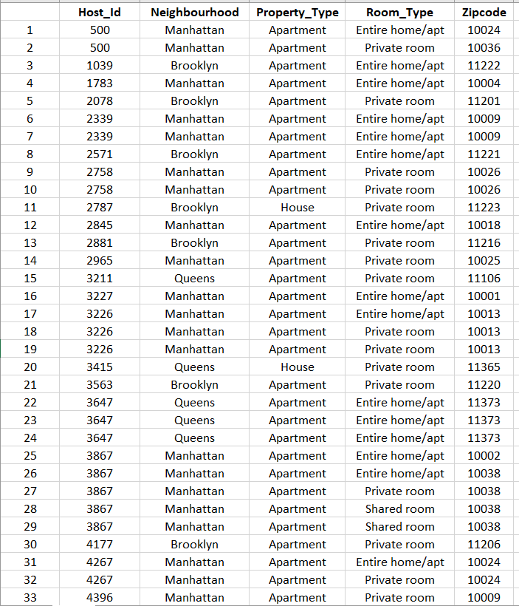

1. **File3.csv**

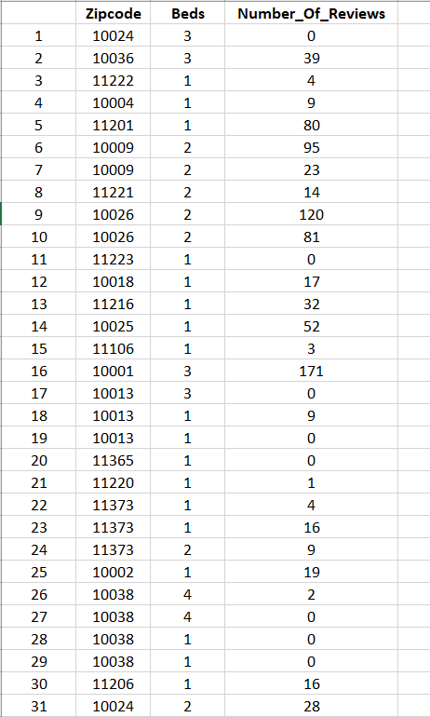

1. **File4.csv**

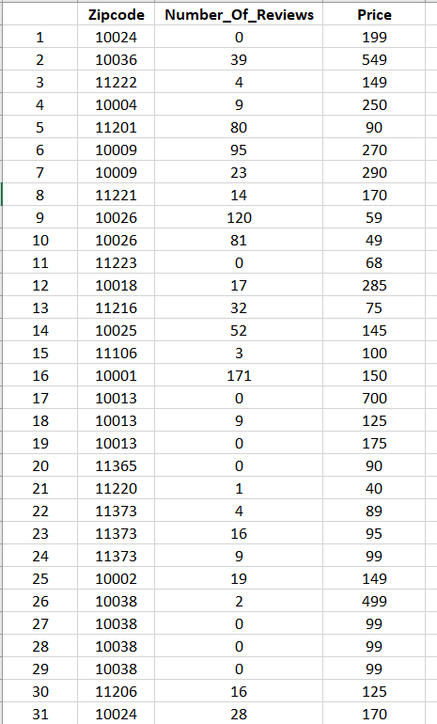

1. **File5.csv**

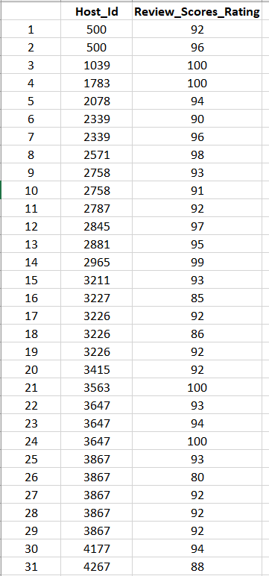

**DashBoard**

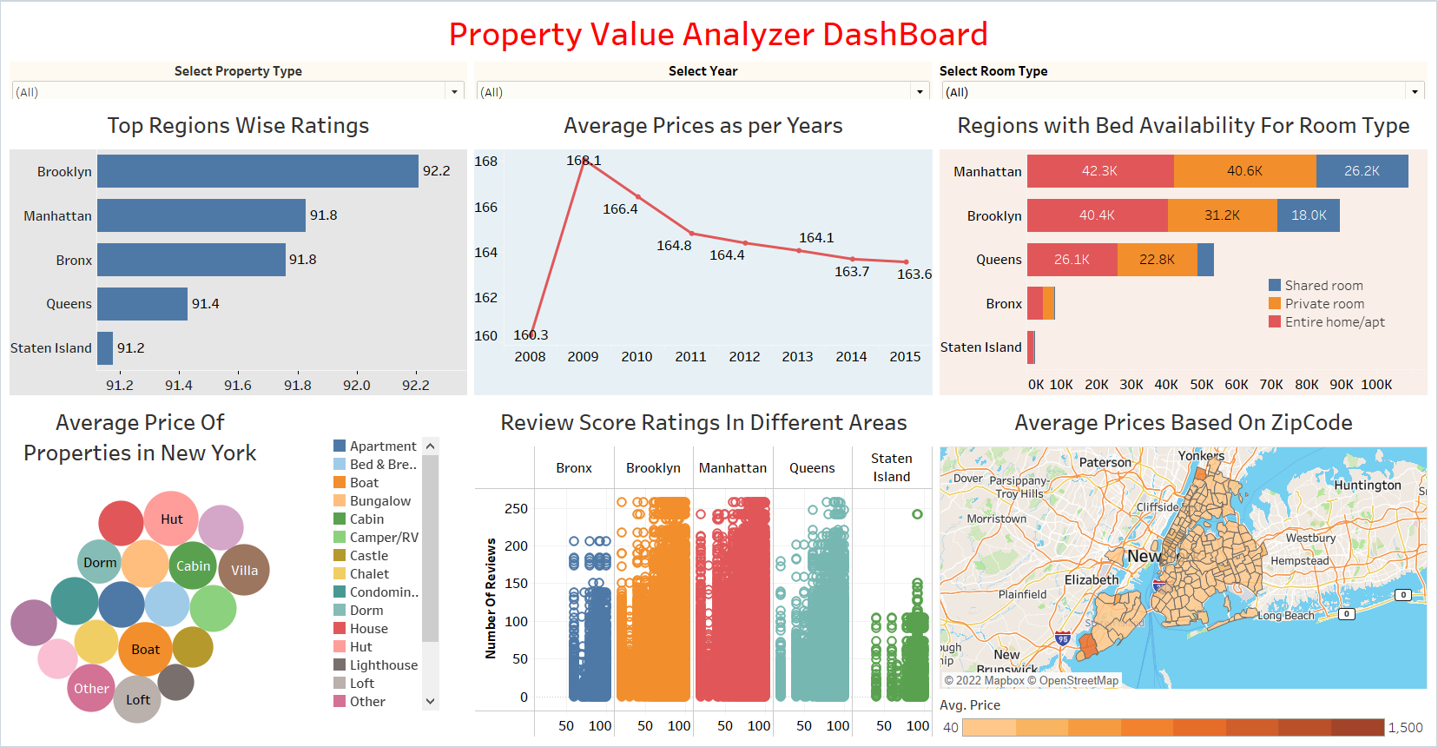

**Merging of Csv Files in Tableu**

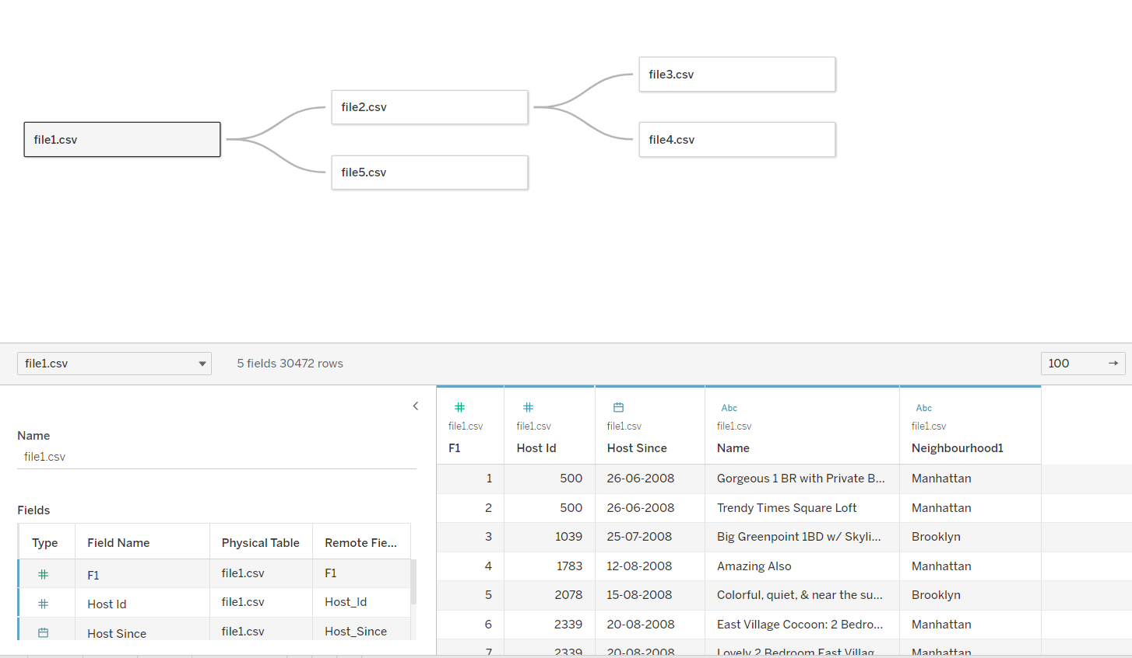

**Filters:**

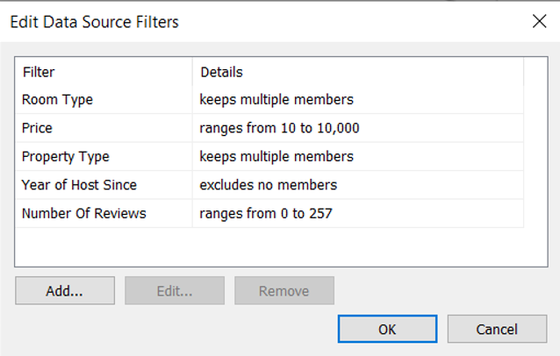

**Queries**

1. **Average Prices Based on ZipCode**

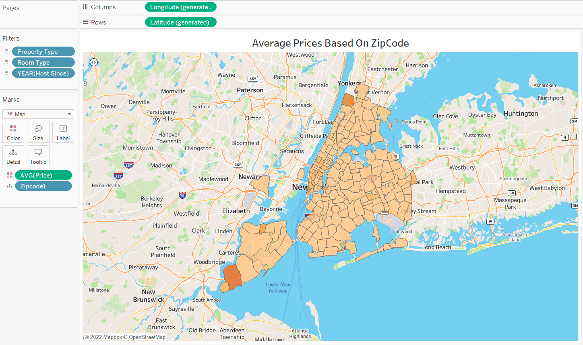

1. **Top Regions Wise Ratings**

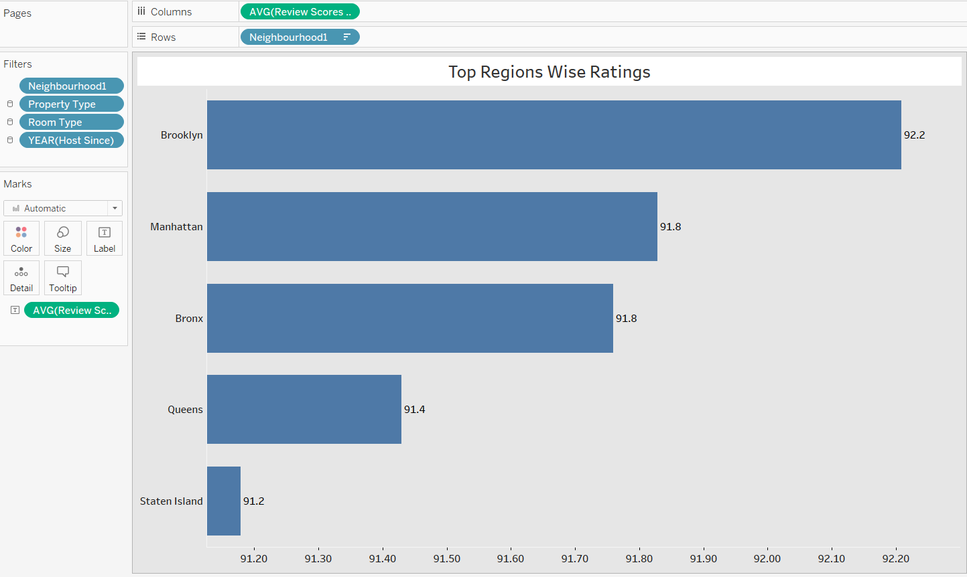

1. **Regions with Bed Availability For Room Type**

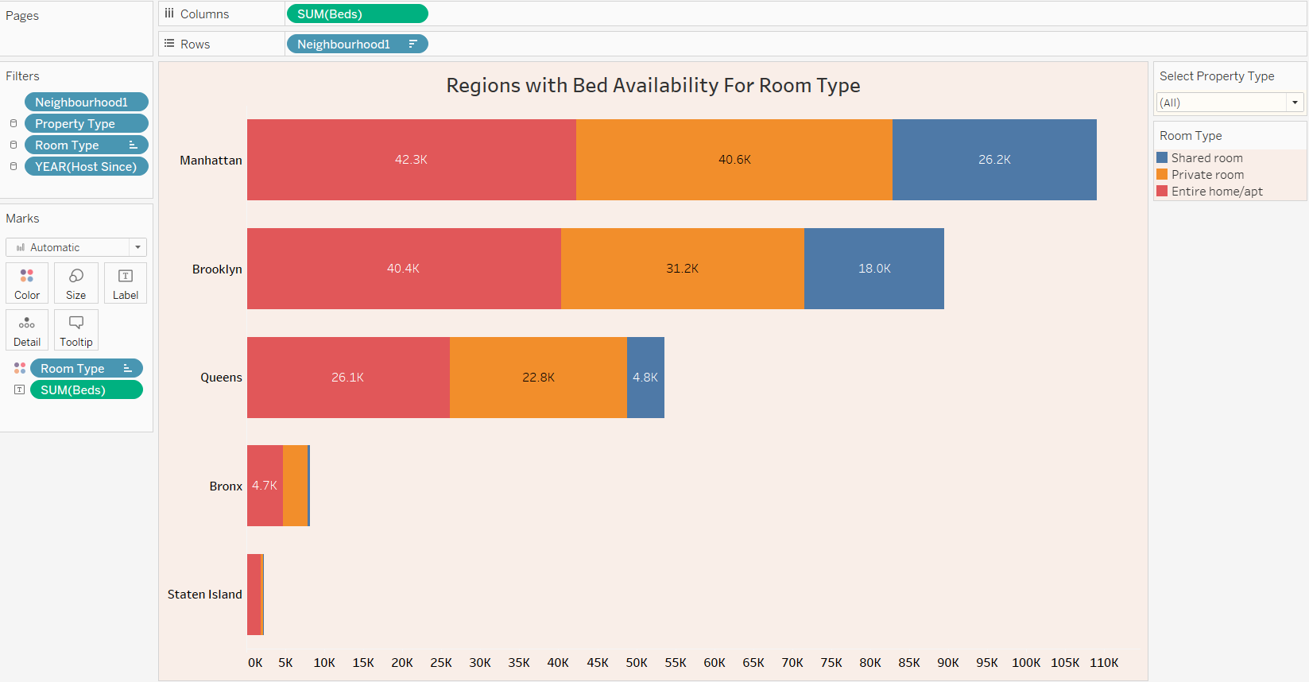

1. **Average Prices as per Years**

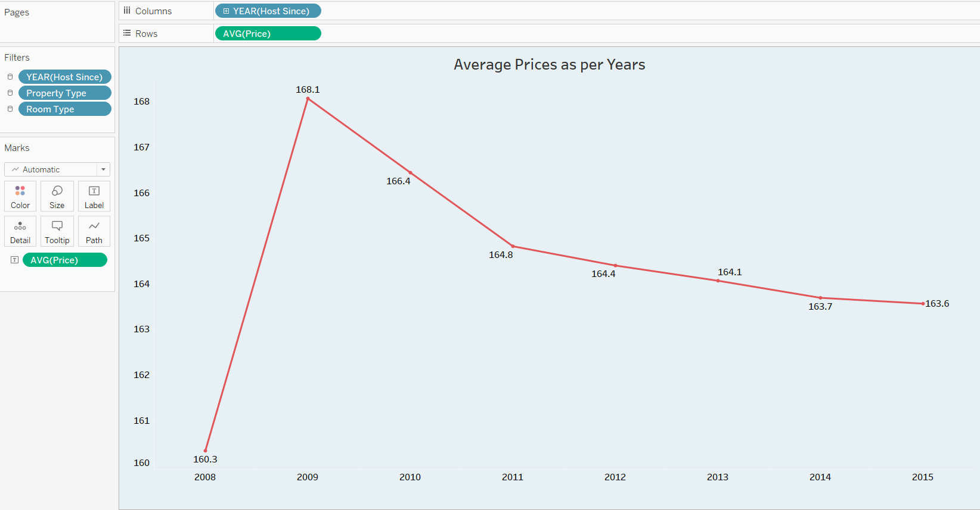

1. **Average Price of Properties in NewYork**

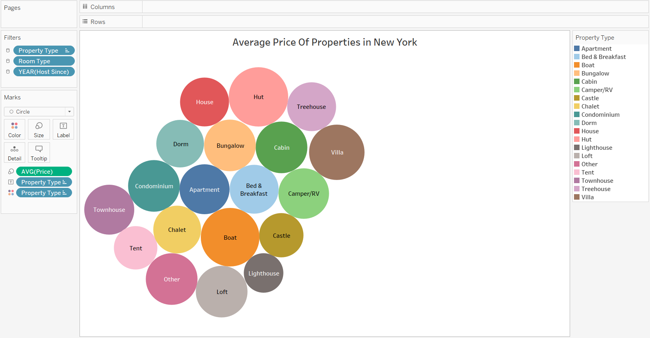

1. **Review Score Ratings In Different Areas**

